LAB PROGRAMS
Experiment 1: Select Distinct Department ID from Employees File
Aim
To write a Pandas program to read the employees dataset and display the distinct department IDs.
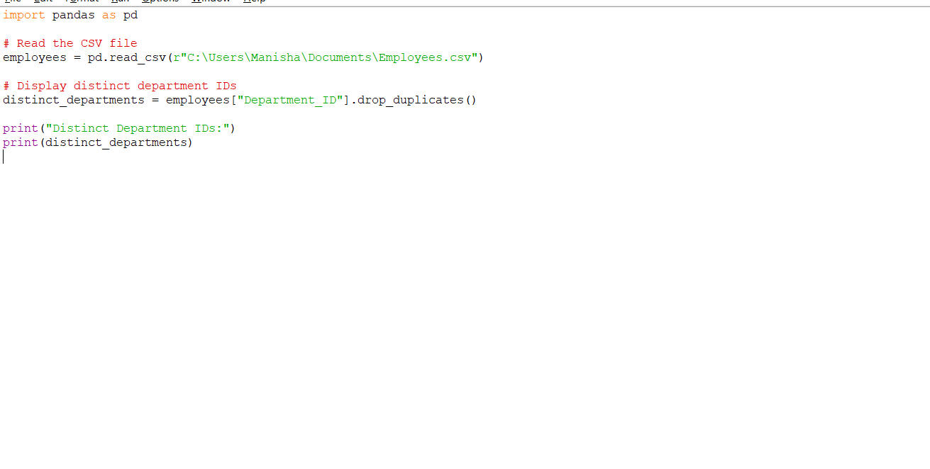
OUTPUT:
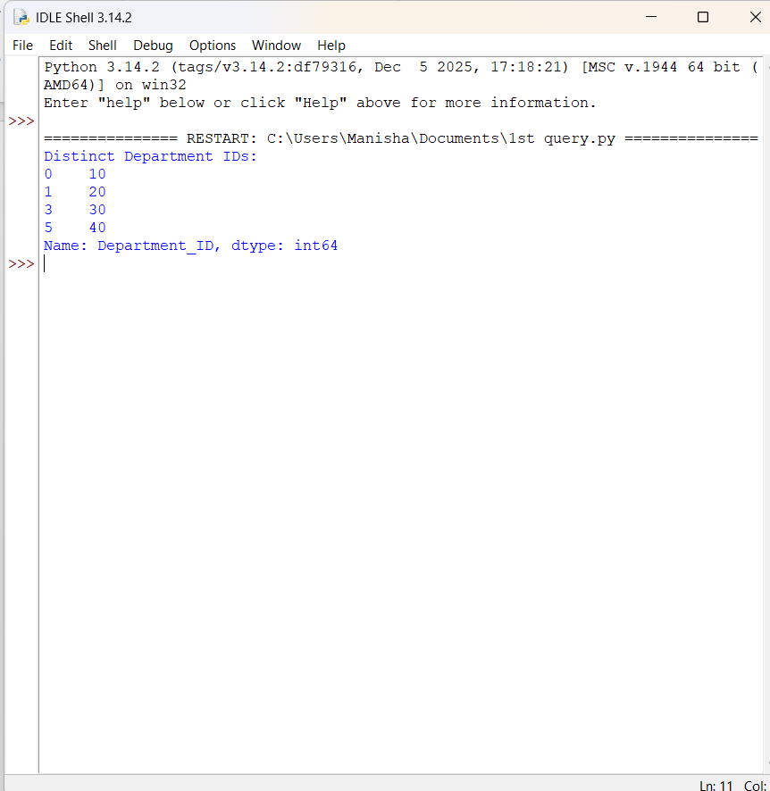
Result
The employees dataset was successfully read using Pandas, and the distinct department IDs were displayed using the drop_duplicates() method.
Experiment 2 Write a Pandas program to display the IDs of employees who have done two or more jobs.
Aim
To write a Pandas program to display the IDs of employees who have done two or more jobs.

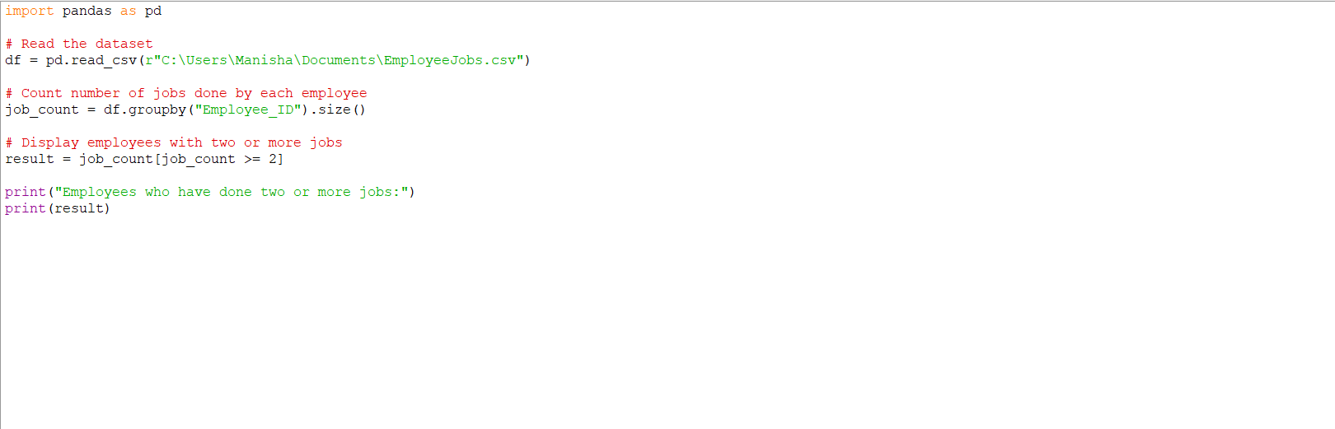
OUTPUT:
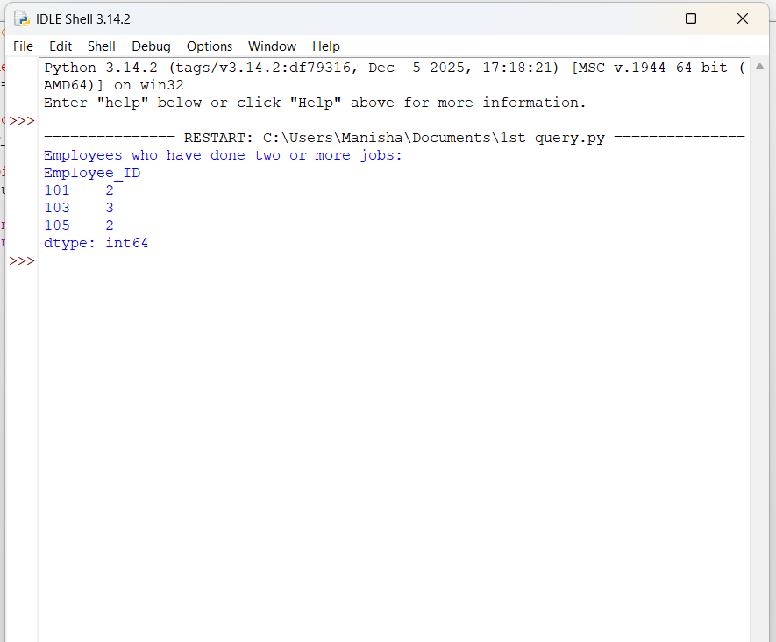
Result
The employee IDs who have completed two or more jobs were successfully displayed using the groupby() and size() functions in Pandas.

3.Write a Pandas program to display the details of jobs in descending sequence on job
Aim
To write a Pandas program to display the details of jobs in descending order based on the job title using Pandas.
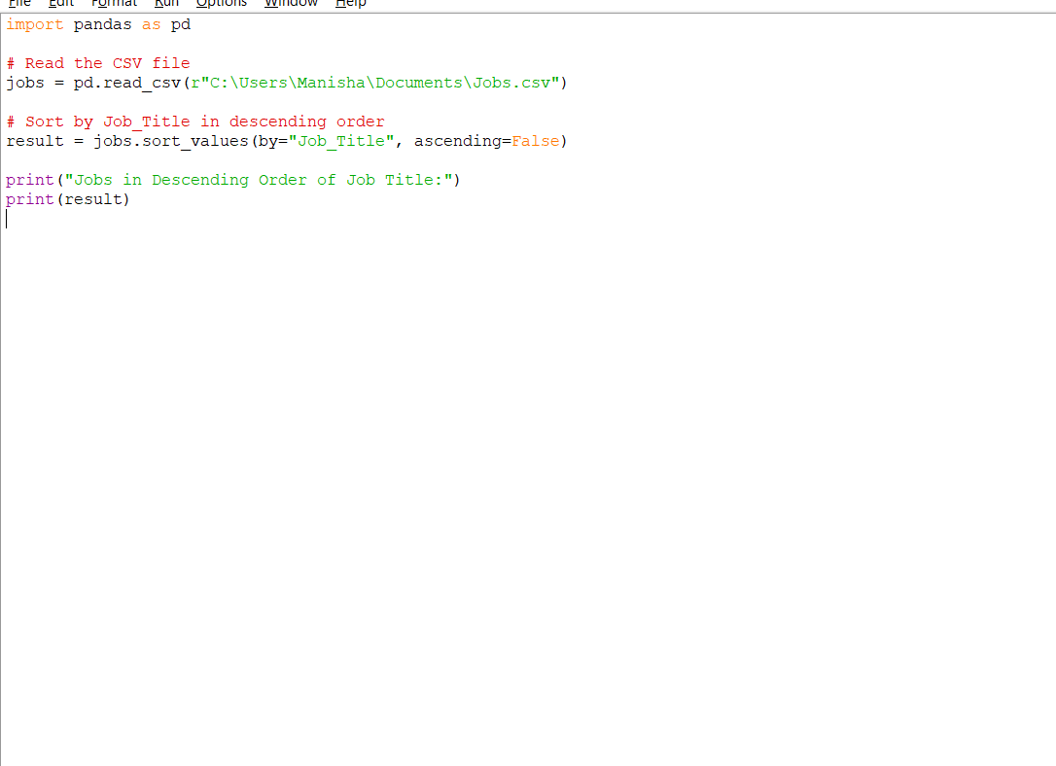

OUTPUT:
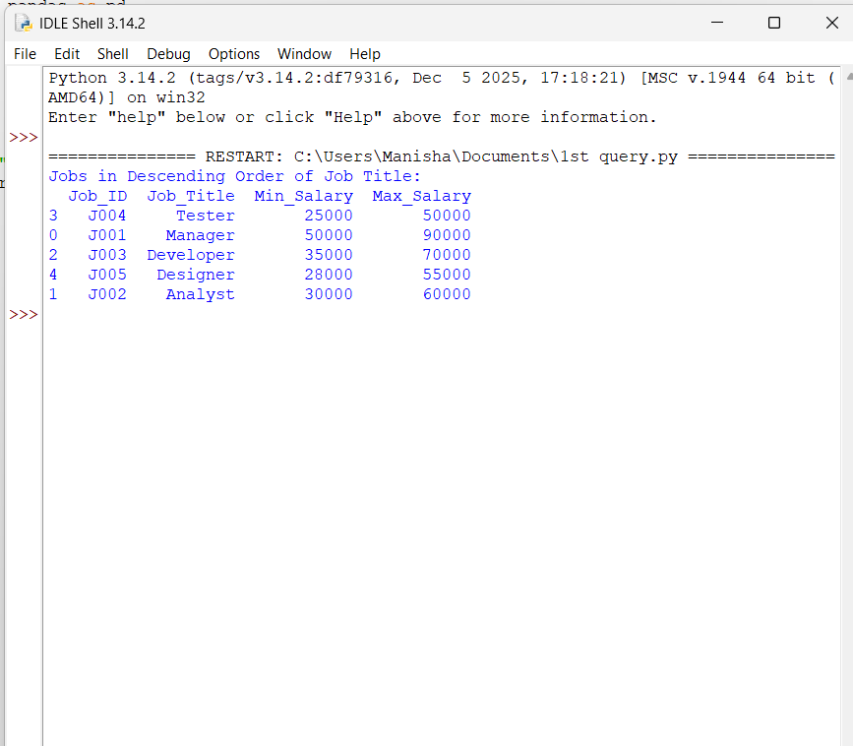
Result
The details of the jobs were successfully displayed in descending order based on the Job_Title column using the sort_values() function in Pandas.

4.Write a Pandas program to create a line plot of the historical stock prices of Alphabet
Aim
To write a Pandas program to create a line plot of the historical stock prices of Alphabet Inc. between two specific dates.
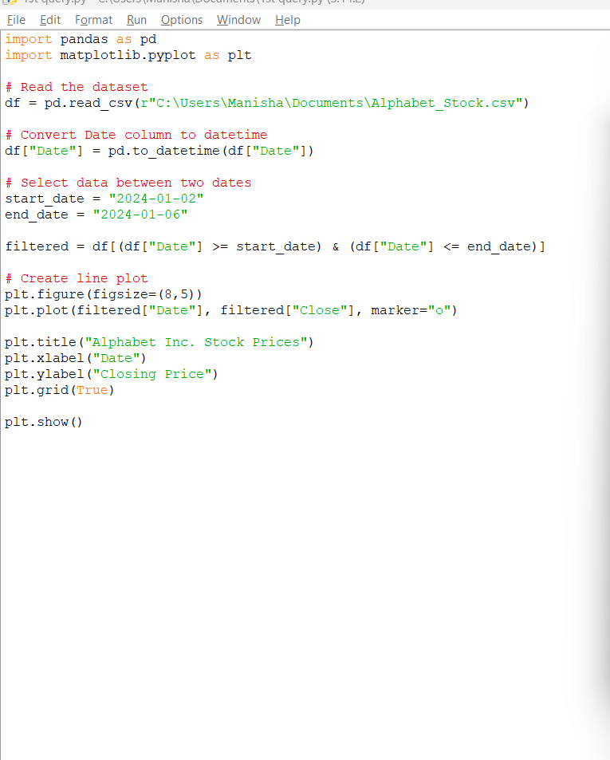

OUTPUT:
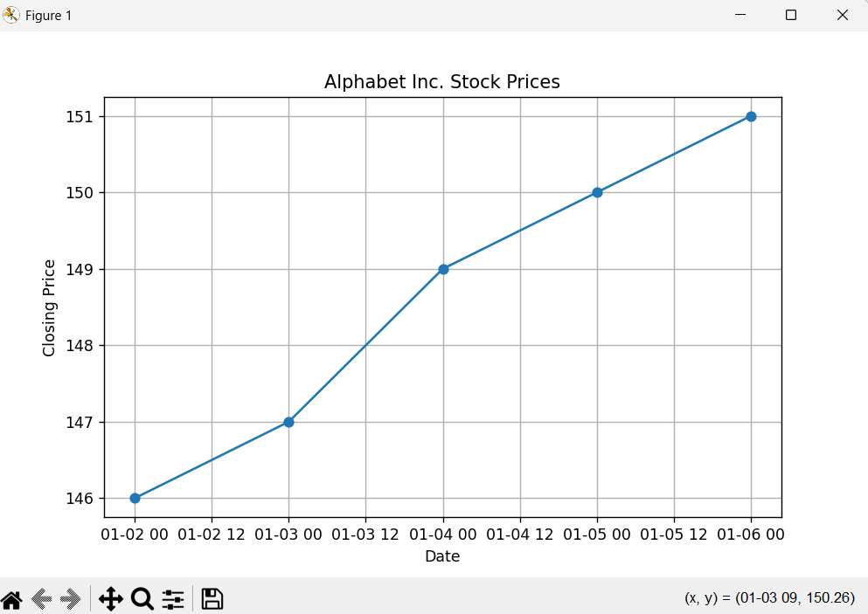
Result
The historical stock prices of Alphabet Inc. between the specified dates were successfully filtered and displayed as a line plot using Pandas and Matplotlib.
5.Write a Pandas program to create a bar plot of the trading volume of Alphabet Inc.
stock between two specific dates.
Aim
To write a Pandas program to create a bar plot of the trading volume of Alphabet Inc. stock between two specific dates using Pandas and Matplotlib.

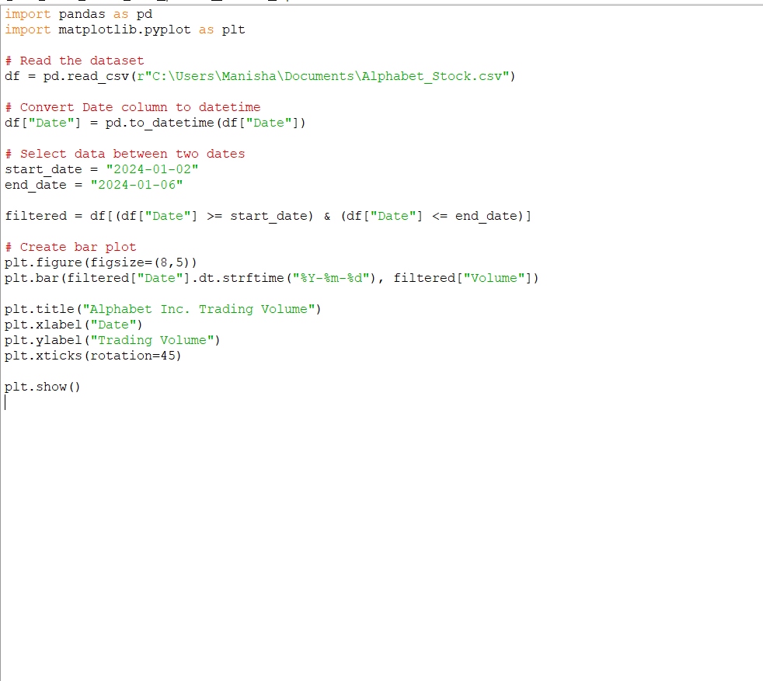
OUTPUT
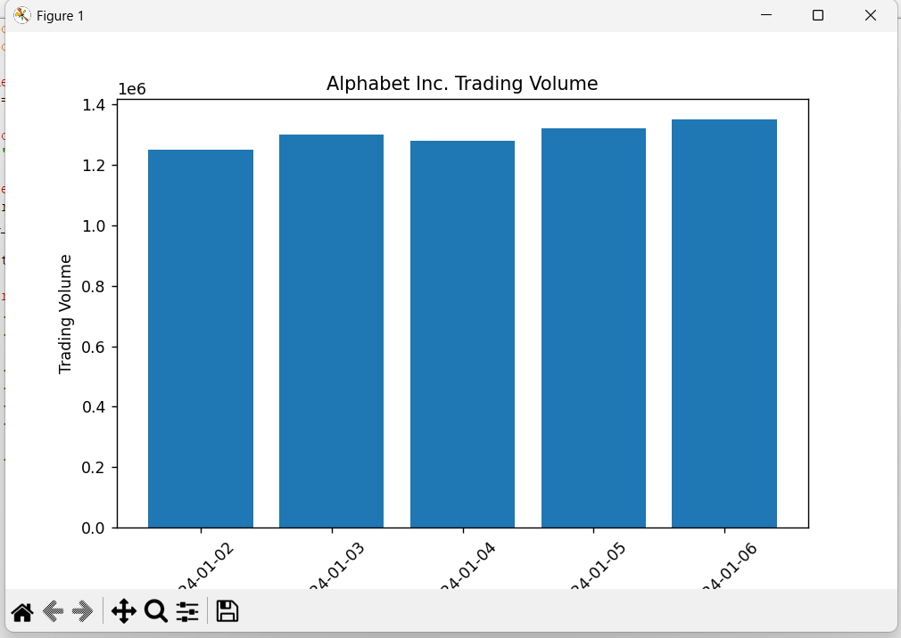
Result
The trading volume of Alphabet Inc. stock between the specified dates was successfully displayed as a bar plot using Pandas and Matplotlib.

6.Write a Pandas program to create a scatter plot of the trading volume/stock prices of
Alphabet Inc. stock between two specific dates.
Aim
To write a Pandas program to create a scatter plot of the trading volume and stock prices of Alphabet Inc. between two specific dates using Pandas and Matplotlib.
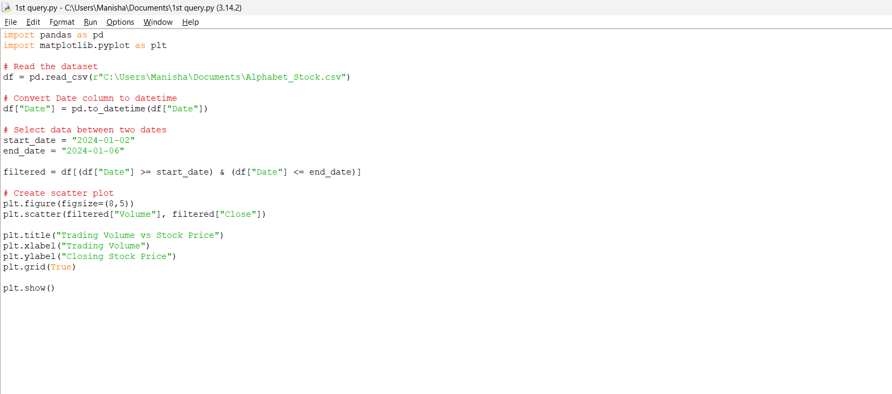
OUTPUT
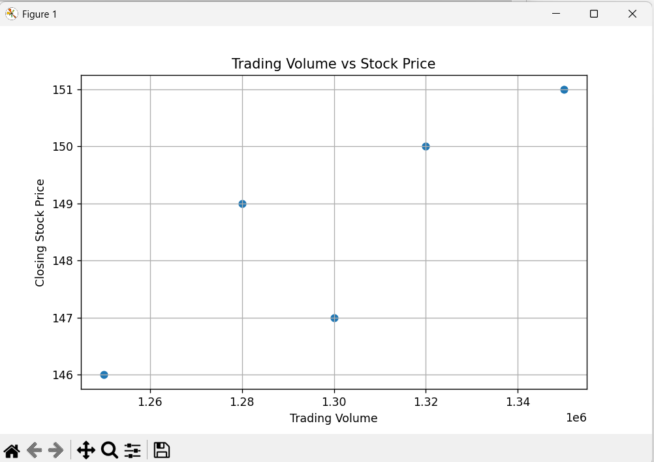
Result
The trading volume and closing stock prices of Alphabet Inc. between the specified dates were successfully displayed using a scatter plot with Pandas and Matplotlib.

